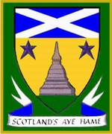

Menu

Pass around Canapés
Vietnamese spring roll with dip
Mini Mushroom Vol au Vents
Mini bacon cheese quiche

Supper
Smoked Salmon, small salad and lemon dressing, dill sauce
Or
Avocado, mango quinoa and salad with lime dressing (V)
****
Scotch Vegetable Broth
****
Haggis, Bashed Neeps and Champit Tatties (Veg Haggis)
****
Cranachan
****
Cheeseboard
****
Coffee, Tea and Tablet

